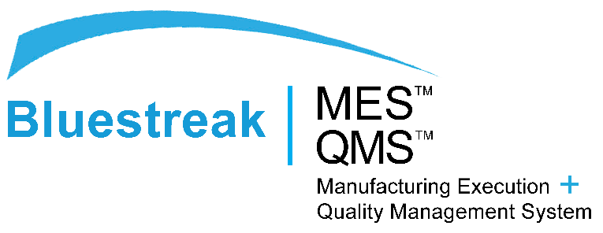

For Immediate Release

Throughput I Bluestreak™ — A Diamond Sponsor of the Powder Coating Institute

DELAFIELD, WI, June 16, 2017 — THROUGHPUT I Bluestreak™, a Manufacturing Execution System, for service- based manufacturers, announces its continued support of the Powder Coating trade by participating as a Diamond sponsor of the Powder Coating Institute, (PCI), the worldwide voice of the industry.

PCI currently represents the North American powder coating industry, promotes powder coating technology and communicates the benefits of powder coating to manufacturers, consumers, and government. Todd Wenzel, President of Throughput Consulting Inc., states, “It is an exciting time to be involved with this industry because rising applications across end-use industries (automotive, aerospace, industrial, and consumer goods), are driving the powder coating market demand. The opportunity to align ourselves with PCI was a logical decision that made business sense. We would definitely recommend it to any powder coating business and other suppliers as well.”

About Throughput I Bluestreak™

BLUESTREAK™ Suite of Products is designed exclusively for a service-based manufacturing environment, where the primary focus is processing and not inventory management. Any service-based manufacturing company can easily customize BLUESTREAK™ to mirror unique business workflows. Find out more at go-bluestreak.com, LinkedIn, Facebook, Twitter, and YouTube.

###

